**Exercise 3 – Branching and Merging.**

* Creating a new branch using **`git branch <branch-name>`**



* Switching to the new branch using **`git switch**` (git checkout is not preferred nowadays)

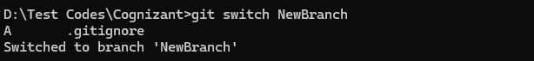

* Listing all the available branches using **`git branch -a`**

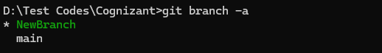

The asterisk (*) specifies the current branch.

* **Adding** new files in this branch, **staging** and **committing** it.

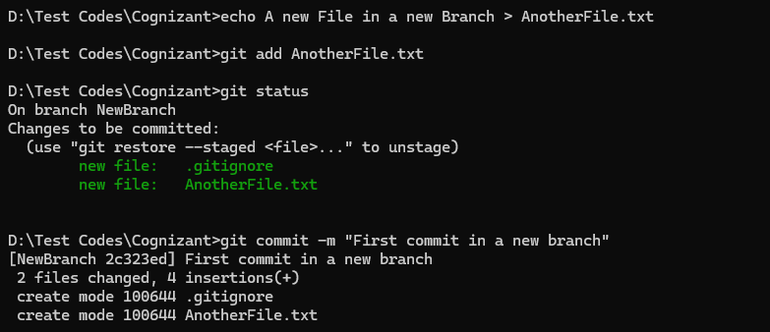

* Checking the status for the last time

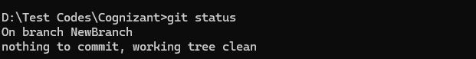

**Merging:**

* Switching to main branch



* Checking differences between main and NewBranch

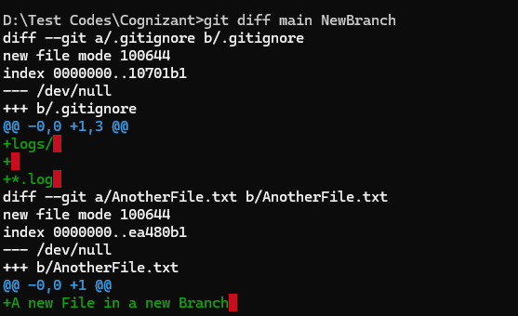

* Merging Both branches

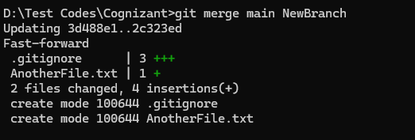

* Visualising the Branches

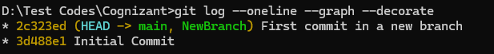

* Deleting the “NewBranch”

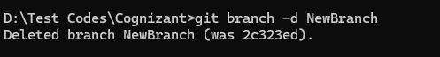

* Checking the status after deletion

